Template for Transnational Cooperation Activities

Type of event:
For which sector(s):
School EducationVocational Education and TrainingHigher EducationAdult EducationYouth

Key action(s) targeted:
KA1KA2KA3

Budgetary year: 2020

Hosting country: FR

Coordinating National Agency: Agence Erasmus+ France / Education Formation

Partner National Agency(s): IH2EF - Institut des hautes études de l’éducation et de la formation (Institute for advanced studies in education and training) in Poitiers

Title of event: Visite d’étude / Study visit:

Fight against gender stereotypes: in communication, school socialization, educational and teaching practices, pedagogical tools, as well as in school guidance and career guidance (access of girls to scientific and technical subjects, career opportunities ...).

Event organiser FRENCH NATIONAL ERASMUS+ Agency
name: | phone number: | email address:
Christelle Coët-Amette | 0033/5 56 90 27 06 | christelle.coet-amette@agence-erasmus.fr
Partnership with IH2EF
Caroline Grandpré | 0033/6 46 10 12 62 | caroline.grandpre@education.gouv.fr

Starting date of the event: 06/04/2020 (starting at 14.00)

Ending date of the event: 09/04/2020 (ending at 14.00)

Event venue (city, country): Poitiers, (Chasseneuil du Poitou) France

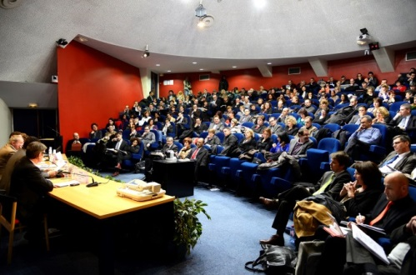
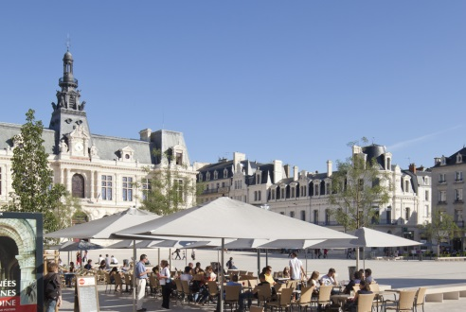

Working language: ENGLISH

Number of places in total: 30 composed of 22 European & 8 French people (a minimum of 15 participants is required)

Profile of participants: The study visit is targeted at school inspectors (primary and secondary schools), trainers, school leaders, educational, social and health personnel, experts, guidance counsellors, ministerial representatives.
Active participation is expected. The participants should be prepared to share their experiences and suggest a tool or practice which seems relevant in its country regarding the fight against gender stereotypes.

Themes and goals of the event:
How to fight against gender stereotypes? What educational policy is implemented? What actions in terms of communication, school socialization? What are the innovations in educational and teaching practices to fight against gender stereotypes? How to make sure that school & career guidance is giving equal opportunities and advices for girls and boys? How to make sure that the access of girls to scientific and technical subjects is fair?

The participants should be interested in exchanging and developing good practices, methods, materials, tools, pedagogical approaches and/or ways of working in this specific field. Participants would also get information on Erasmus+ & eTwinning opportunities for further cooperation.

Expected results: Sharing experiences, practices and educational policies with other specialists from all over Europe on the topic. Meeting projects, experts and participate actively to workshops in order to enrich practices. Discovering Erasmus + opportunities to go further at European level.

Programme of event: from Monday mid-day to Thursday 14.00. The study visit includes:
- expert presentations;
- study visits to educational sights in the Poitiers area;
- joint discussions and workshops;
- Erasmus+ information.

Event’s webpage (if applicable):

Travel information: Poitiers is served by an airport and connected to many cities in Europe by high speed train station especially from Paris.

Event fee (amount in EUR, if applicable): fees covered by the organizers

Travel costs (who cover the travel costs): to be covered by the sending Erasmus+ National Agencies

Number of participants per country: max 2

Deadline to which NAs inform organizer about number of participants, they will send: 17/01/2020
Application deadline : 17/02/2020
Deadline to which organizer confirms number of places reserved: 28/02/2020
Deadline for sending details of participants to hosting NA: 4/03/2020

Types of participant’s data sending to the organizer: Name/Surname/Organisation/Sector/address and phone

Is National Agencies staff welcome? no

